NOS-120 Chapters 4 and 5

Log into NDG and workstation virtual Classroom Machine to complete this quiz.

1. Type the command to give the system manual page for the ls command.

Insert Screenshot Below:

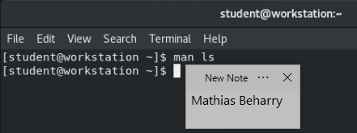

1. From within the man page for the ls command search forward for the keyword “inode”.

Insert Screenshot Below:

**Inputting: /inode**

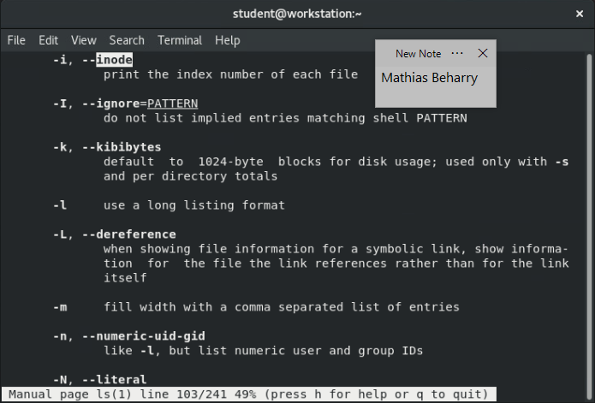

1. Type the command to redirect the output of the ll /home to a file named quiz.

Insert Screenshot Below:

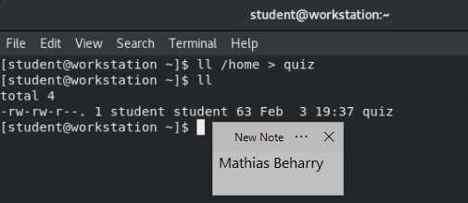

1. Use vi to edit the file quiz and add your name as the last line of text.

Insert Screenshot Below:

